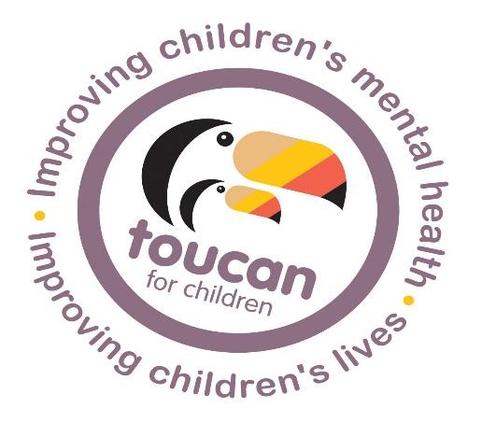





ARE YOU WORRIED ABOUT

YOUR CHILD?
Are they angry, sad, struggling at school, or having difficulties with friends/family? Have they experienced some sort of trauma?
At Toucan for Children we offer therapy through play and creative arts which can improve self esteem, reduce anxiety, improve peer relations and improve school performance.

Suitable for 3-14 yrs
Family waiting room
Bases in Mitcheldean
And Gloucester

Minimal waiting times
Experienced therapists
Support with funding

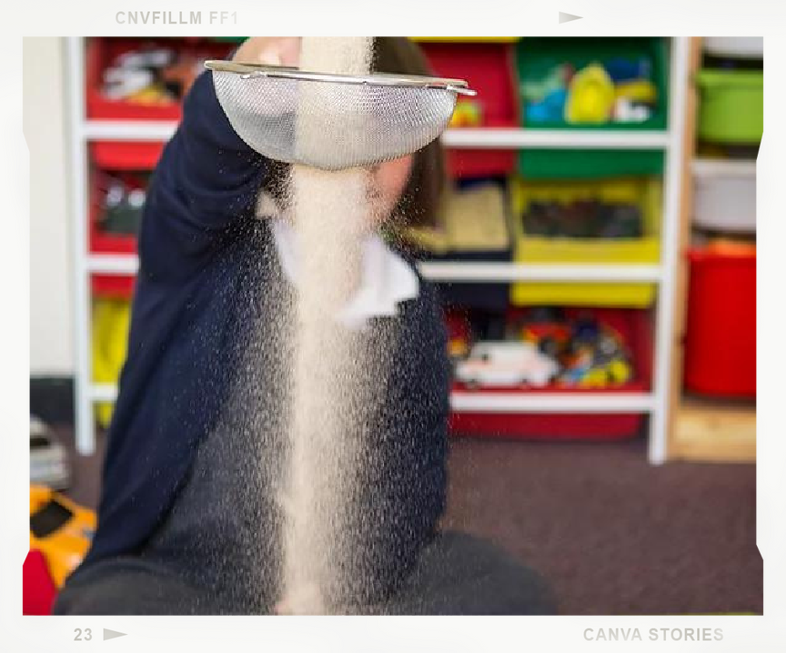
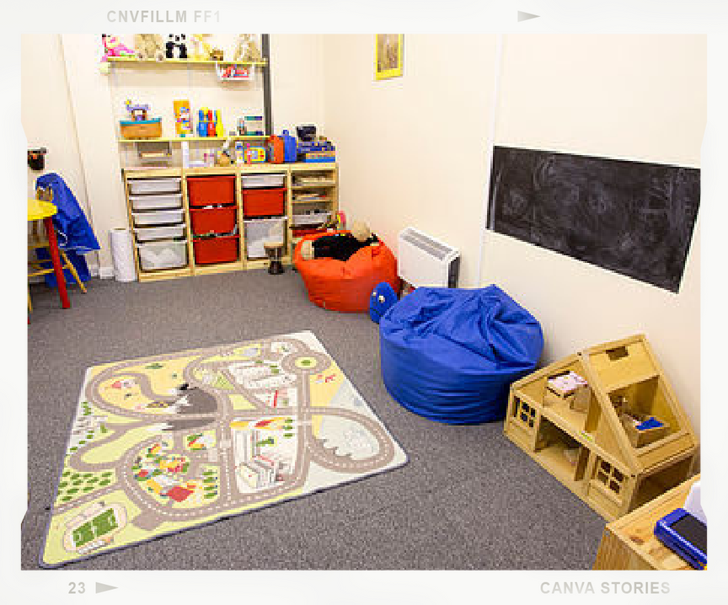
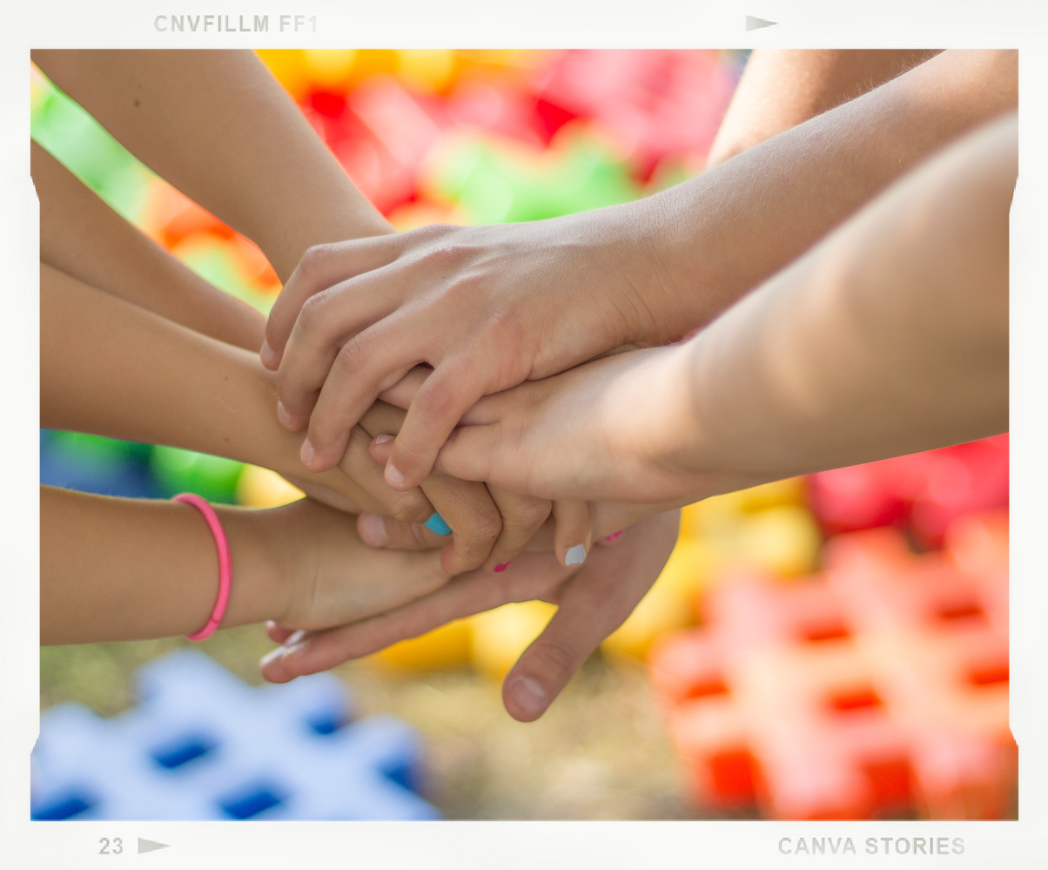
Contact us for an informal chat and let's see how we can help.
Call us on 07526 245880 or email admin@toucanforchildren.co.uk

