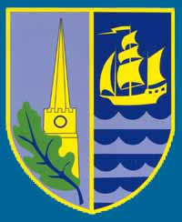
A caring Christian community where every child achieves a love of life and of learning

Dear Parent/Carer,
Just a reminder that school is able to issue food bank vouchers; please do not hesitate to get in touch if you need one. You can contact the office to ask for these, or mention to a staff member that you feel comfortable speaking to, and someone will contact you. The school is also able to issue more vouchers to support you over the summer holidays.
The foodbank centres are located in Lydney, Coleford and Cinderford and their opening times are detailed on Locations | The Forest Foodbank
Alternative places that can issue food bank vouchers are also detailed on the website but include St James Church, Bream (who also operate the ‘fridge’ scheme to prevent food waste) and The Salvation Army (details can be found on the above website).
Food Bank centres are more than food! The Food Banks also have CCP (Caring for Communities and People) advisers and will soon have Citizen’s Advice representatives there also, who will be able to offer advice for a variety of reasons.
Can we also give a reminder of the HAF programme which provides FREE activities for those in receipt of free school meals (not including universal free school meals in KS1). Details of this and how to sign up can be found here, Holiday Activities and Food programme (HAF) - Gloucestershire County Council
Additionally, school may be able to find support for things like school uniform if this is an issue for you. Please do ask.
We recognise that it can be difficult to ask for support but please don’t feel like you are alone. Many others have asked before you, and will after you. Information shared is confidential and will only be shared with those who we are seeking support from and then only with your consent.
Many thanks

Lucy Nelmes
SEND and Inclusion Lead
The Severn Federation Academy Trust.

