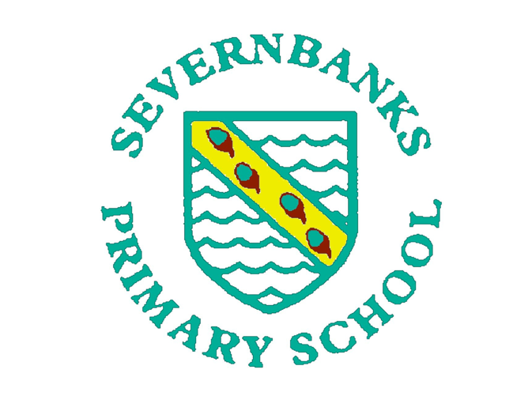


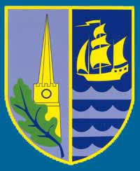

The Severn Federation Trust is registered as an agency to issue Foodbank vouchers. If you require support in this way, please email:
inclusion@sfat.uk
or the admin team at the school your child/ren attend:
admin@aylburton.gloucs.sch.uk
admin2@lydney.gloucs.sch.uk
admin@bream.gloucs.sch.uk or admin2@bream.gloucs.sch.uk
admin@severnbanks.gloucs.sch.uk
admin@englishbicknor.gloucs.sch.uk

We will contact you as soon as possible to discuss your needs. All information will be treated sensitively and confidentially, only sharing information with those required to provide the support you need.
Note: the centres for the Foodbanks in the Forest of Dean are in Coleford and Cinderford. They are not currently delivering to homes so you will need transport to get to a centre. If this is in no way possible, we can contact the Foodbank to try to arrange a delivery under special circumstances. This will be up to the Foodbank Network to decide if this is possible.
Families can be issued with up to 3 vouchers in a 6 month period but if more are required, it may be possible through discussion with the Foodbank Network.

