

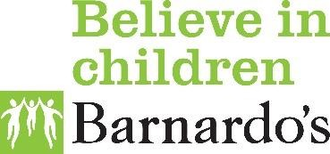
Barnardo’s HAF
Community Connectors
Forest of Dean and Stroud

We can support you with the following:
- Help you sign up to CABS system and book activities.
- Fund and organise transport.
- Signpost you to support in the community.
- Give advice and guidance and answer enquiries.
- Support to access food over the school holidays.

Find out more about HAF by visiting www.gloucestershire.gov.uk/haf/

- Help you sign up to the CABS system and book onto activities.
- Fund and organize transport.
- Signpost you to support in the community.
- Give advice and guidance and answer enquiries.
Support to access food over the school holidays

Contact us…
Monday to Friday 9:30 am -4:30 pm
01594 806876
BarnardosHAF@barnardos.org.uk





