

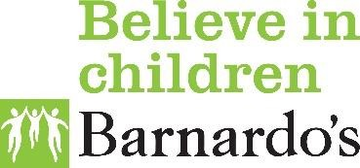
Barnardo’s HAF
Community Connectors
Forest of Dean and Stroud
We can support you with the following:
- Attending activities and events where a need has been identified.
- Promote activities & events and work alongside providers/district leads to distribute to those most in need.
- Reaching out to families when referred by a provider or district lead.
- Organising transport and appropriate clothing.
- Signposting and referring to other agencies and community support.

- Help you sign up to the CABS system and book onto activities.
- Fund and organize transport.
- Signpost you to support in the community.
- Give advice and guidance and answer enquiries.
Support to access food over the school holidays

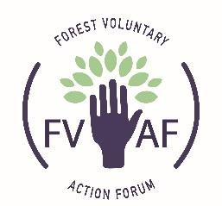

Contact us…
Monday to Friday 9:30 am -4:30 pm
01594 806876
BarnardosHAF@barnardos.org.uk



