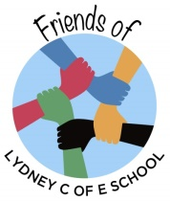

The Friends of Lydney C of E School are a small group of parents/guardians/grandparents that organise social and fundraising events to raise money for the school and to help enhance our children’s school experience.

Children throughout the school enjoy the many activities we organise, and the money raised goes towards a number of things, including:

- Book bags for Reception Class
- Coaches for the Christmas pantomimes
- Leavers’ presents and parties for Year 6
- Crackers for Christmas lunch
- Playground equipment

We’re always looking for more volunteers to join our friendly group. Everyone is welcome and any contributions of time/ideas/help – no matter how small, even an hour for a one off event or help behind the scenes – are much appreciated!

Please come along and join us at one of our upcoming meetings. You’ll find more information on Facebook on the Lydney C of E School Friends page, about all our events and meetings. (Don’t forget to ‘like’ us there too!). Or email us at friends@lydney.gloucs.sch.uk

Fundraising Events

Raffles Discos Challenge Week Christmas Cards Christmas Fayre

Cake Sales Uniform Sales Summer Fayre Non-Uniform Days



